006BC2744 - Day 18 (10 August 2026)

Redirecting Output (> and >>)

ls > files.txt
ls > files.txt lists the files/directories in the current directory and redirects the output into files.txt instead of displaying it on the terminal.

echo "New entry" >> files.txt
Appends "New entry" to the end of files.txt without deleting existing content.

echo -e "banana\napple\ncherry" > fruits.txt
Creates/overwrites fruits.txt with banana, apple, and cherry on separate lines.

ls /not_a_real_folder 2> errors.txt
Attempts to list a non-existent folder; the error message is redirected to errors.txt instead of being displayed on the terminal.

ls | wc -l
Lists files/directories in the current directory and counts the number of lines (entries) in the output.

ps aux | grep bash
Displays running processes and filters the output to show processes containing bash, such as active Bash shells.

ps a — Shows processes running on the current terminal/TTY, including processes of other users.

ps au — Shows processes in a detailed, user-oriented format, including the user, PID, CPU/memory usage, and command.

ps aux — Shows all running processes from all users with detailed information such as CPU, memory, start time, and command.

du -sh * | sort -rh | head -5
This command finds the 5 largest files/directories in the current directory and displays them in descending order of size.

du -sh * → Shows the disk usage of each file/directory in a human-readable format
sort -rh → Sorts the results by size in reverse (largest to smallest) order.
head -5 → Displays only the first 5 lines, i.e., the 5 largest items.

./script.sh > /dev/null 2>&1

Individual parts
./script.sh → Executes the script.sh shell script from the current directory.
> → Redirects standard output (stdout).
/dev/null → Discards whatever is sent to it.
2> → Redirects standard error (stderr).
&1 → Sends stderr to the same destination as stdout (/dev/null).

Task 1: Sed
Pick some dummy data .. and keep it in a file myFile.ttx

What will this command do
Sed myFile.txt
Can you replace a word with another
S → search for 1st occurrence of any old keyword and change it with new in your file..
sed 's/old/new/' filename
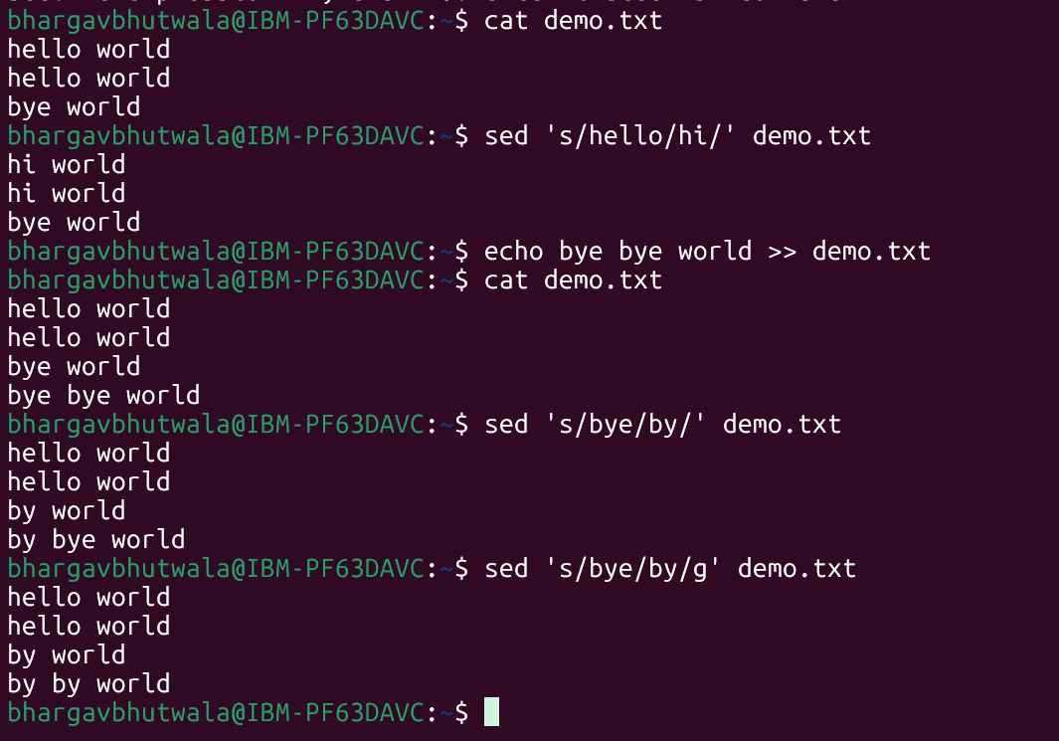
Try with delete flag
sed '/word/d' filename

Print specific line numbers line line 3 of your file

sed -n '3p' filename

Print range of lines

Like from line 2 to 5
sed -n '2,5p' filename

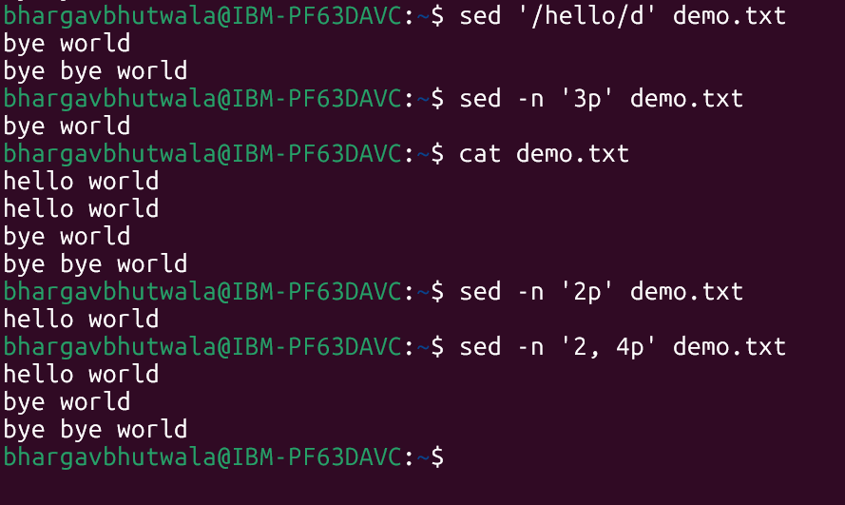

Task 2: Awk (used for pattern scanning and processing)

Now try same with awk
awk '{print}' filename

Print specific column
awk '{print $2}' filename

Print multiple columns
awk '{print $1, $3}' filename

Filter rows by giving condition
Like print 1st nd 3rd column only if 3rd column value is > 50 fo example..

awk '$3 > 50 {print $1, $3}' filename

Use custom delimiter (comma , is a delimiter operator) and print first 2 fields..

awk -F, '{print $1, $2}' filename (here f is filed separator (demiliter))

Now count lines
awk 'END {print NR}' filename (nr is no of records..)

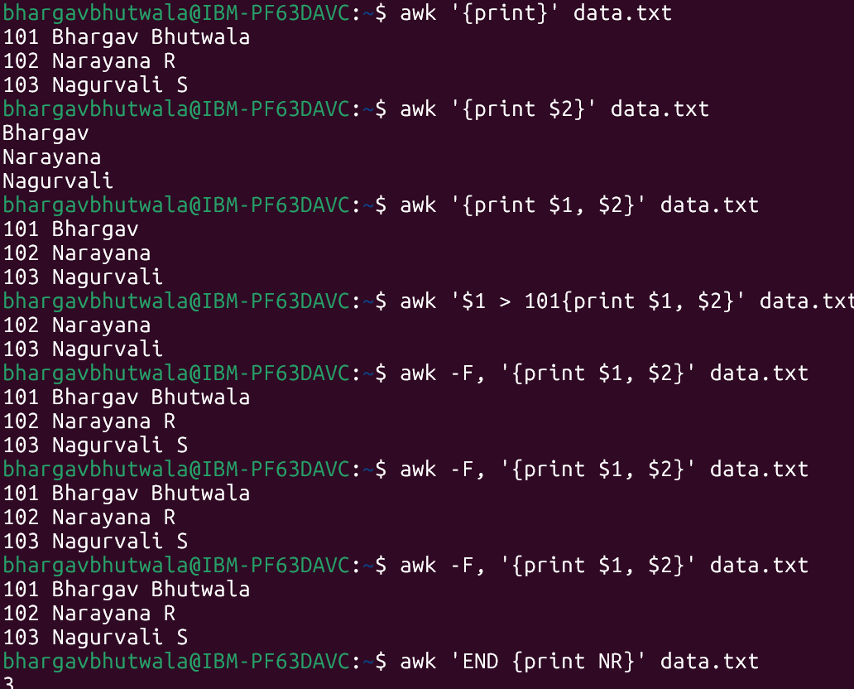

Task 3:

Ping google.com

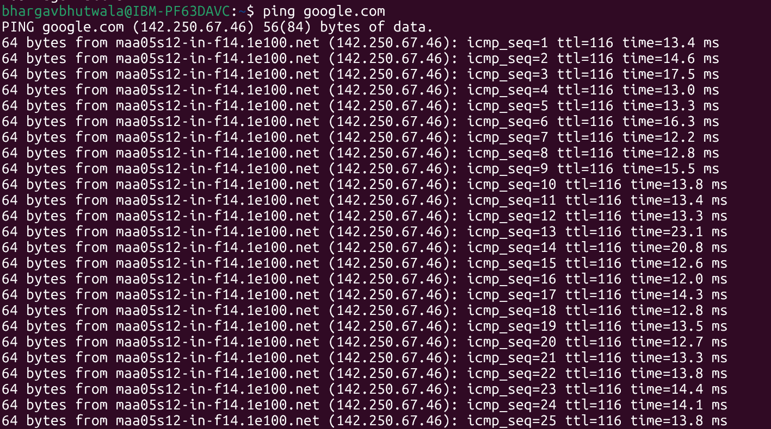

Curl https://google.com

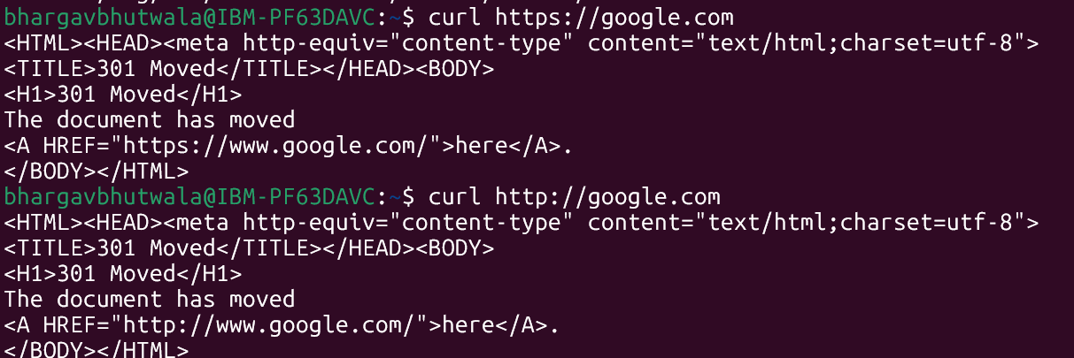

Netstat -an

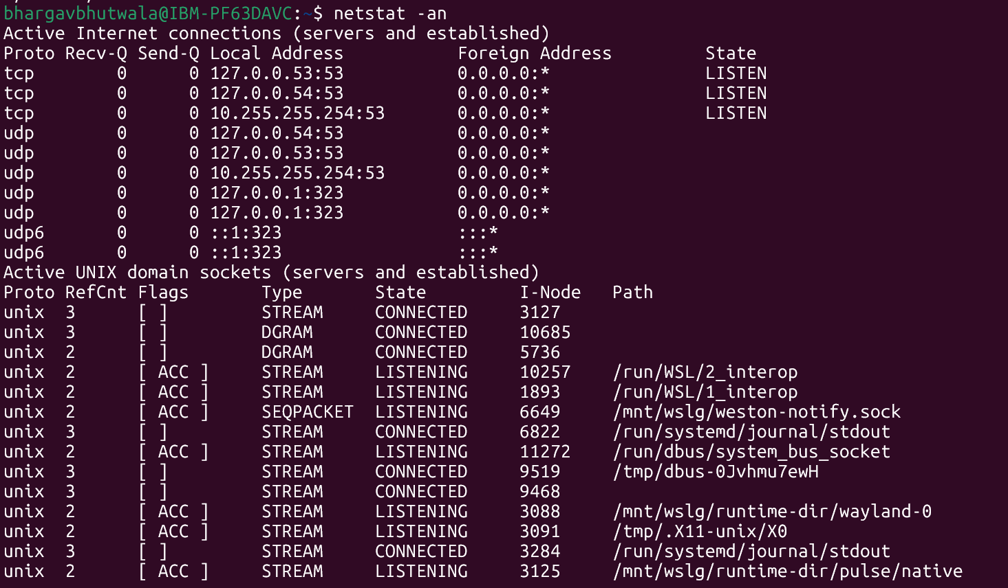

Task 4: Generate a certificate signing request (CSR)

openssl genrsa -out localhost.key 2048

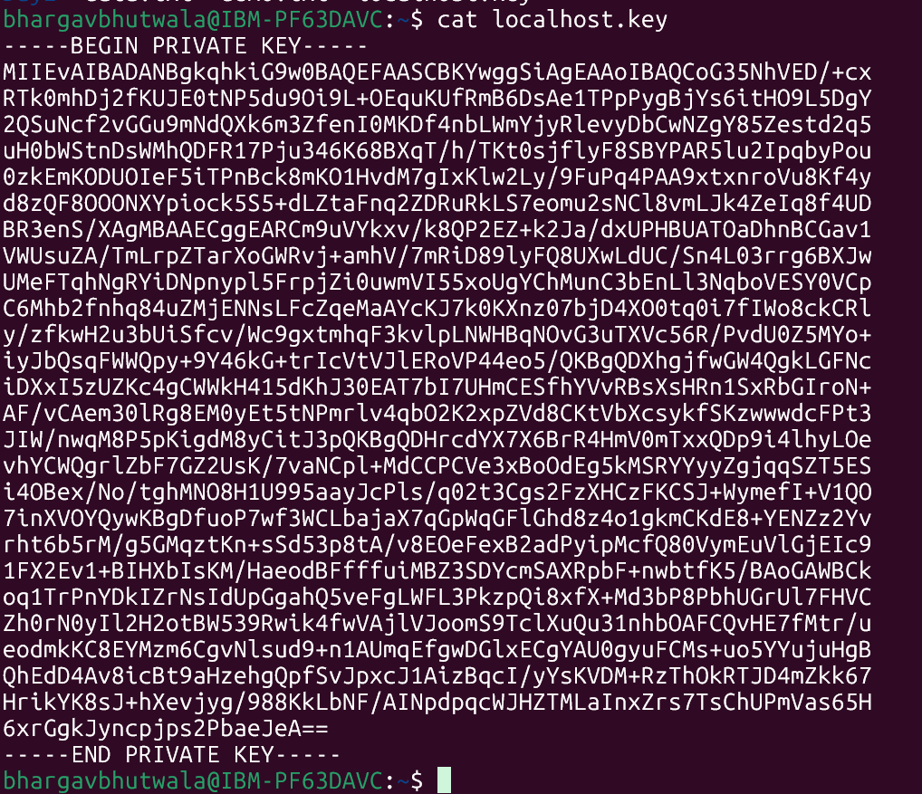

Step 3:

Generate a self‑signed certificate
In bash
openssl x509 -req -days 365 -in localhost.csr -signkey localhost.key -out localhost.crt

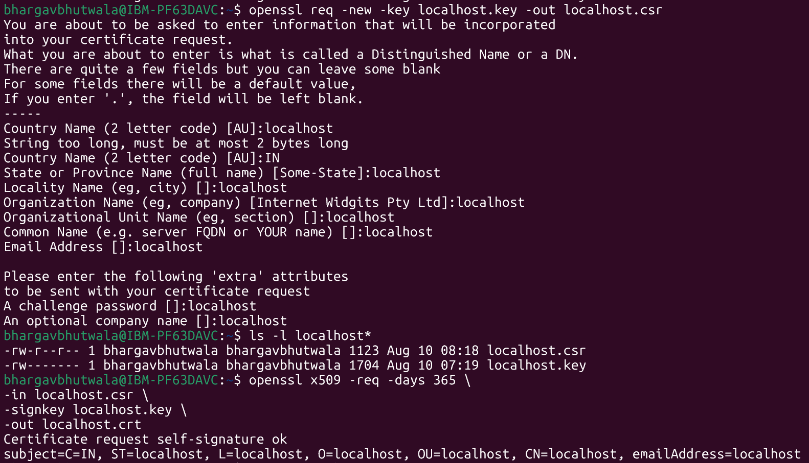

Step 4:

Now Start a Simple HTTPS Server
Use Python: `python -m http.server 4443 --bind 127.0.0.1 --ssl-certfile cert.pem --ssl-keyfile key.pem`.

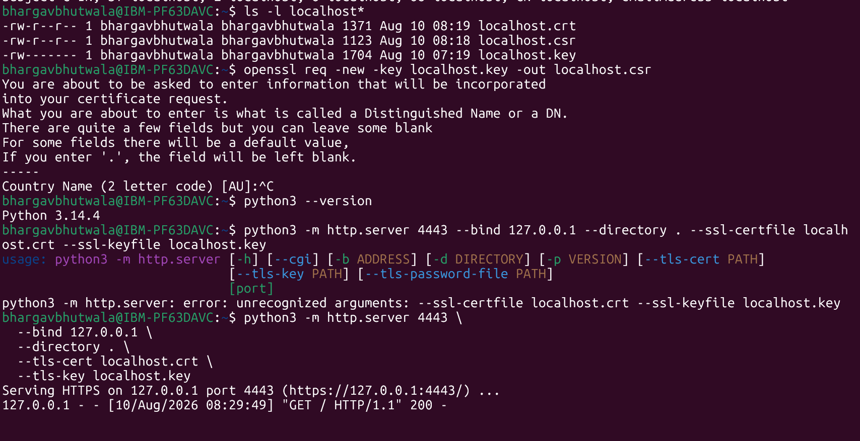

Step 5:
Now Test with Browser or Curl
Visit https://localhost:4443 or run `curl -k https://localhost:4443` to see encrypted communication.

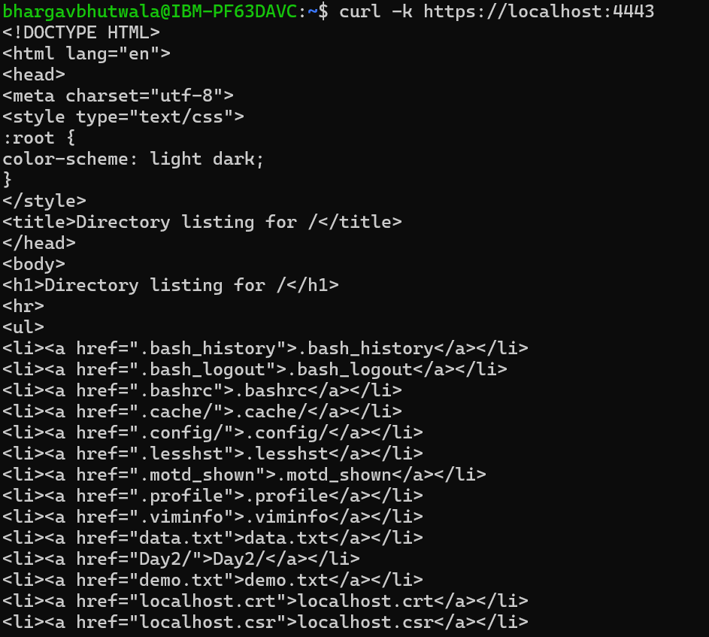

Step 6:

Did u Observe TLS Handshake
Use Wireshark or `openssl s_client -connect localhost:4443` to watch how TLS negotiates keys and ciphers.

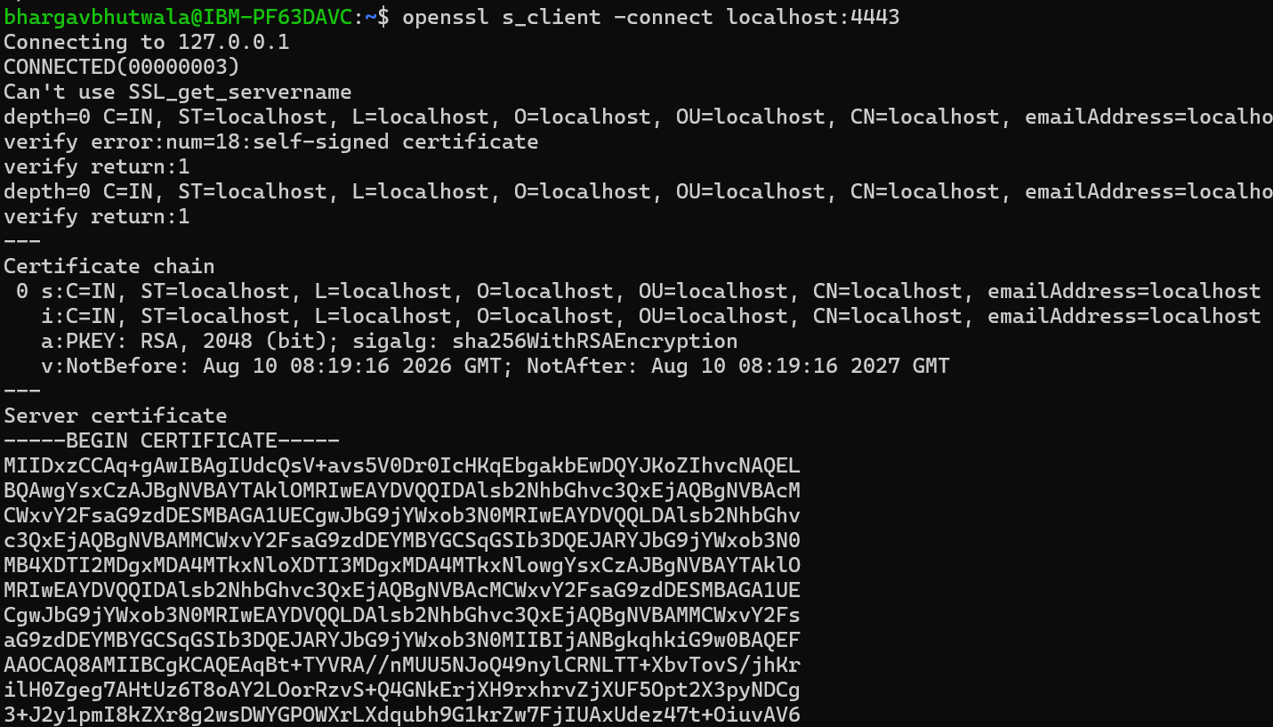

Step 7:

Verify Certificate Trust
Browsers will warn about self-signed certs; in real deployments, use CA-issued certificates for trust.

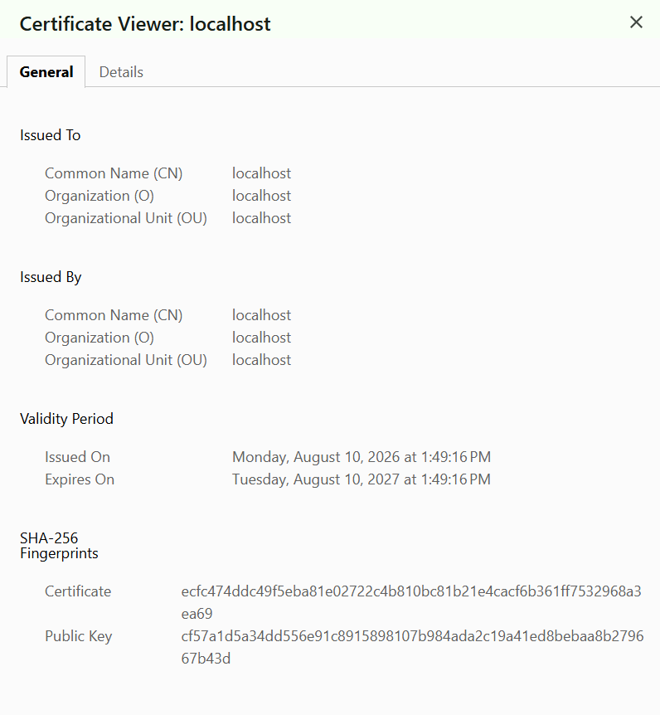

Task 5: What are trees ? Where do you implement them?

A tree is a hierarchical data structure made of nodes connected by edges, with one root node and zero or more child nodes.
Trees are used in file systems, databases, HTML DOM, searching, sorting, and decision-making systems such as Binary Search Trees and decision trees.

Task 6: Can you give types of trees?

Common types of trees include Binary Tree, Binary Search Tree (BST), AVL Tree, Red-Black Tree, Heap, B-Tree, and Trie.
They are used for different purposes such as fast searching, sorting, priority management, database indexing, and storing strings efficiently.

Task 7: What is a binary search tree?

A Binary Search Tree (BST) is a binary tree where each node has at most two children, and values in the left subtree are smaller while values in the right subtree are larger than the node.
This structure allows efficient searching, insertion, and deletion, with average time complexity of O(log n).

Task 8: Can you create a simple binary tree using a node and insert values in it?

Like in java

class Node {
int val;
Node left, right;
Node(int val) { this.val = val; }
}

Insert values in left side and right side of the nodes and display the tree values

public class BinaryTree {

class Node{

int val;
Node left, right;

public Node(int val){
this.val = val;
}
}

Node root;

Node insert(Node root,int val){
if(root==null){
return new Node(val);
}

if(root.val > val){
root.left = insert(root.left,val);
}
else if(root.val < val){
root.right = insert(root.right,val);
}
return root;
}

void inorder(Node root){
if(root==null){
return;
}
inorder(root.left);
System.out.print(root.val + " ");
inorder(root.right);
}

public static void main(String[] args) {

BinaryTree tree = new BinaryTree();

// Insert values
tree.root = tree.insert(tree.root, 50);
tree.root = tree.insert(tree.root, 30);
tree.root = tree.insert(tree.root, 70);
tree.root = tree.insert(tree.root, 20);
tree.root = tree.insert(tree.root, 40);
tree.root = tree.insert(tree.root, 60);
tree.root = tree.insert(tree.root, 80);

System.out.println("Tree values (In-order):");

tree.inorder(tree.root);
}
}

Task 9: Now extend the above code to search a no in your list.

// Search for a value
boolean search(Node node, int val) {

// Value not found
if (node == null) {
return false;
}

// Value found
if (node.val == val) {
return true;
}

// Search left subtree
if (val < node.val) {
return search(node.left, val);
}

// Search right subtree
return search(node.right, val);
}

Task 10: Now can you do Inorder traversal in your bst?

void inorder(Node root){
if(root==null){
return;
}
inorder(root.left);
System.out.print(root.val + " ");
inorder(root.right);
}

Task 11: What is the fundamental difference between BFS and DFS?

BFS (Breadth-First Search) explores a graph/tree level by level, typically using a Queue.
DFS (Depth-First Search) explores as deep as possible before backtracking, typically using a Stack or recursion.

Task 12: Which underlying data structures are used to implement BFS and DFS?

BFS (Breadth-First Search) explores a graph/tree level by level, typically using a Queue.
DFS (Depth-First Search) explores as deep as possible before backtracking, typically using a Stack or recursion.

Task 13: How do you find the shortest path in an unweighted graph?

In an unweighted graph, use BFS (Breadth-First Search) because it explores nodes level by level.
The first time you reach the destination, the path found is the shortest path in terms of number of edges.

Task 14: How do you detect a cycle in a graph?

For an undirected graph, use DFS/BFS and track the parent node; if you visit an already-visited node that is not the parent, a cycle exists.
For a directed graph, use DFS with a recursion stack; reaching a node already in the current recursion stack indicates a cycle.

Task 15: Explain the internal working of a HashMap.

A HashMap stores key-value pairs using a hash function to calculate a key’s hash and determine its bucket/index.
If multiple keys map to the same bucket (collision), Java handles them using a linked structure/tree, and operations like put() and get() use equals() to find the exact key.

Task 16: Which property of a hashmap is used to find the intersection of two arrays?

The key uniqueness property of a HashMap is useful for finding the intersection of two arrays, because duplicate keys are stored only once.
You can store elements of one array as keys and then check whether elements of the second array exist as keys in the HashMap.

Task 17: What is collision in HashMap?

A collision in a HashMap occurs when two different keys produce the same hash bucket/index.
Java handles collisions using a linked list or balanced tree within that bucket, while equals() identifies the correct key.

Task 18: How Does Java's Capacity And Size Of Hashmap Differ?

Capacity is the number of buckets a HashMap has available to store entries, while size is the actual number of key-value pairs currently stored.
For example, a HashMap can have a capacity of 16 but a size of 5, meaning 5 entries are currently stored in 16 buckets.

Task 19: Does hashmap allow you to store null values?

Yes, We can store as many null values in a hashmap as we want but only one null key can be stored, not more than that.

Task 20: hashmaps in Java are not thread-safe.can you justify?

Java’s HashMap is not thread-safe because multiple threads can modify it simultaneously, potentially causing race conditions and inconsistent data.
For concurrent access, use ConcurrentHashMap or synchronize access using appropriate locking mechanisms.

Task 21: Can you store multiple keys with the same value in a hashmap?

Yes, a HashMap can store multiple different keys with the same value, because keys must be unique but values do not have to be.
For example: map.put("A", 100) and map.put("B", 100) are both valid entries.

Task 22: Can you tell the differences between a Hashmap and a Hashtable in Java.

HashMap is not synchronized and allows one null key and multiple null values, whereas Hashtable is synchronized and does not allow null keys or values.
HashMap is generally preferred in modern Java applications; for thread-safe use, ConcurrentHashMap is usually preferred over Hashtable.

Task 23: Can you create a java code for bubble sort …

public class BubbleSort {

public static void main(String[] args) {

int[] arr = {5, 2, 8, 1, 3};

for (int i = 0; i < arr.length - 1; i++) {

for (int j = 0; j < arr.length - 1 - i; j++) {

if (arr[j] > arr[j + 1]) {

int temp = arr[j];
arr[j] = arr[j + 1];
arr[j + 1] = temp;
}
}
}

System.out.println("Sorted array:");

for (int num : arr) {
System.out.print(num + " ");
}
}
}

Task 24: Can you create a java code for selection sort …

public class SelectionSort {

public static void main(String[] args) {

int[] arr = {64, 25, 12, 22, 11};

for (int i = 0; i < arr.length - 1; i++) {

int minIndex = i;

// Find the smallest element
for (int j = i + 1; j < arr.length; j++) {

if (arr[j] < arr[minIndex]) {
minIndex = j;
}
}

// Swap
int temp = arr[i];
arr[i] = arr[minIndex];
arr[minIndex] = temp;
}

System.out.println("Sorted array:");

for (int num : arr) {
System.out.print(num + " ");
}
}
}

Task 25: Can you create a java code for linear search …

public class LinearSearch {

public static void main(String[] args) {

int[] arr = {10, 25, 30, 45, 50};

int target = 30;

int index = -1;

for (int i = 0; i < arr.length; i++) {

if (arr[i] == target) {
index = i;
break;
}
}

if (index != -1) {
System.out.println("Element found at index: " + index);
} else {
System.out.println("Element not found");
}
}
}

